CHEN 531
Corrosion
Chemical Engineering
Faculty of Engineering and Architecture
American University of Beirut
Friday November, 16th, 2012
16.00-18.00

This exam paper has 5 questions
Answer all questions
You have two hours to complete this exam

GOOD LUCK

Q1. (a) Discuss three industrial consequences of corrosion problems. (6 marks)
(b) Give two practical examples for each of the following:
  - Dissimilar metal corrosion
  - Differential aeration cells
  - Metals less noble than H₂
(6 marks)
(c) Plot a typical graph of the Pourbaix diagram for iron showing the main regions. How can this diagram help you in designing storage tanks for acids? (5 marks)

(d) Draw a schematic diagram illustrating a typical galvanic cell. Identify the different cell components on the diagram. Show typical corrosion reactions (anodic and cathodic) and identify typical applications in industry. (8 marks)

Q2. Explain the following cases that cannot be predicted by EMF.
- Although iron shows a (–ve) potential, it will not corrode in certain environments.
- Pb does not dissolve in concentrated H₂SO₄
- Al does not dissolve in concentrated HNO₃
- Although Cu and Ag are more noble than hydrogen but they dissolve in KCN with vigorous evolution of H₂ forming the complexes: K₃ [Cu(CN)₄] and K [Ag(CN)₂]
- Although Cu is more noble than hydrogen, it dissolves in HNO₃
(10 marks)

Q3. A stainless steel alloy has the following composition and elemental properties.

Metal | Mass % | Atomic Weight | Valency | Density (g/cm³)
Fe | 70 | 55.8 | 2 | 7.86
Cr | 18 | 52.0 | 3 | 7.10
Ni | 8 | 58.7 | 2 | 8.90
Mo | 3 | 95.9 | 2 | 10.2

Determine the penetration rate of this alloy equivalent to 1 μA/cm² corrosion current.
r (mpy) = 0.129 M.i/(n.ρ)
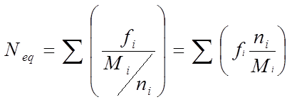
M/n = EW =1/ N_{eq}
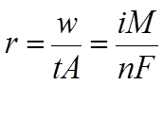
Where:
f_{i} = mass fraction of i^{th} element
n_{i} = electrons exchanged in the i^{th} element
M_{i} = Molar mass (= atomic weight) of i^{th} element
N_{eq} = number of equivalents in unit mass of alloy
EW = equivalent weight of alloy

(12 marks)
Q4. Explain briefly the three different types of polarization giving examples (one example per type). (9 marks)

Q5. (a) Show that the corrosion potential due to activation polarization and the equivalent current (I_{corr}) can be determined mathematically according to the following equations. (14 marks)

E _{cor}r = (b_{c} E_{eq,a} –b_{a} E_{eq,c})/(b_{c}-b_{a}) + b_{c}b_{a}[log₁₀(I_{o,c})-log₁₀(I_{o,a})]/(b_{c}-b_{a})

Log₁₀ (I _{corr}) = (E_{corr}-E_{eq,a} + b log₁₀(I_{o,a}))/b_{a}

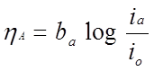
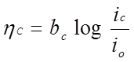

Eeq = equilibrium or Nernst potential

Q5. (b) Find the corrosion potential, E_{corr}, and corrosion current, I_{corr}, for iron (Fe) iron in a deaerated solution at 25°C, pH=5 using the equations in part a and graphically (Evans Charts).
(20 marks)
Anode
Surface area =1 cm2
Io = 10⁻⁶ A
b_{a} = 0.120 V/decade

Cathode
Surface area = 1 cm2
Io = 10⁻⁶ A
bc = 0.120 V/decade

Q5. (c) Show how a limiting current of 1 x 10⁻⁴ A might affect both E _{corr} and I_{corr}.
(10 marks)

END OF EXAM
